**Software Engineering Department**

**Course Name: CMPE272– Enterprise Software Platforms**

Group Name: Team – G

Group Members: Vibhava Rayala, Nirupama Janapati, Pragati Sahu, Varsha Kollu.

Instructor: Andrew Bond

Lab Assignment #4: Building Client application that implements the twitter REST API

**Abstract:**

Twitter is an online social networking service that enables users to send and read short 140- characters messages called "tweets". Third-party Twitter applications are required to use [OAuth](https://en.wikipedia.org/wiki/OAuth), an authentication method that does not require users to enter their password into the authenticating application. Previously, the OAuth authentication method was optional, it is now compulsory and the user-name/password authentication method has been made redundant and is no longer functional. In this assignment, we build a client application that implements 8 API’s of twitter using OAuth. We have created a web application where the user logins onto a JSP (Java Server Page), which in-turn makes him connect to java, the java code checks and authenticates if the user is valid or not by validating the OAuth, If the OAuth gets validated correctly, the user gets connected to JSP through Java, and it invokes the twitter API’s, and displays the contents accordingly. The API’s implemented in this application, display the number of followers, the people we are following, tweets, and retweets etc. The Web application uses Java Server page to get connected to java, the content is displayed on Java server page, and the language used to build this web application is Java.

**Unified Modeling Language (UML):**

The Unified Modeling Language (UML) is a general-purpose, developmental, modeling language in the field of software engineering that is intended to provide a standard way to visualize the design of a system.

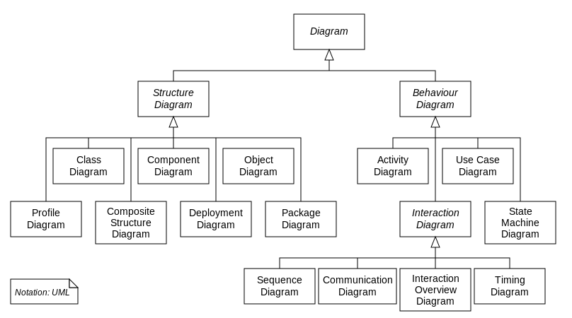

**Use Case:**

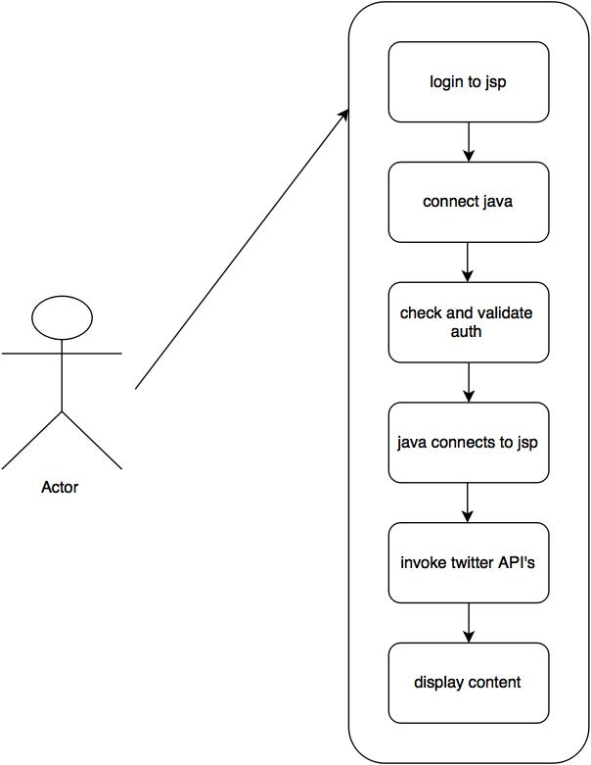

**Activity Diagram:**

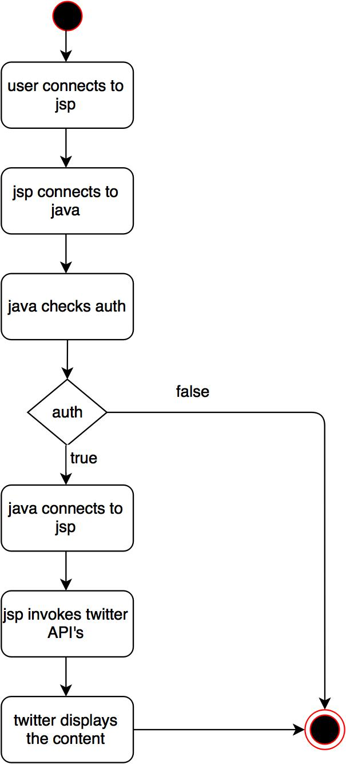

**Collaboration Diagram:**

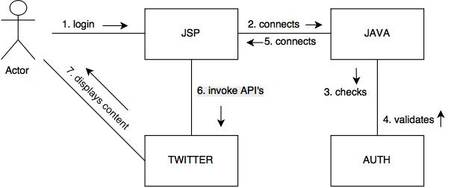

**Sequence Diagram:**

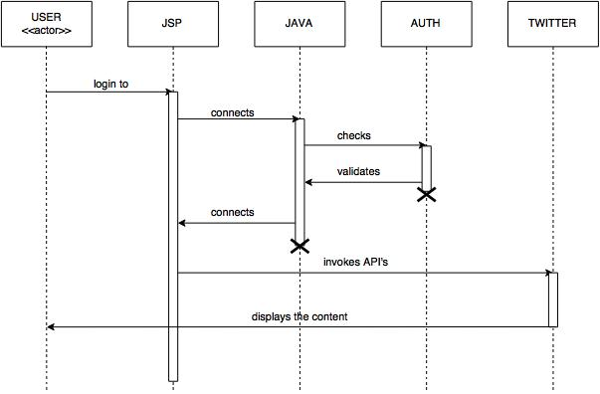

**State Chart Digaram:**

